

**Learning Resources Centre**

**A Guide for Students**

Contents

**About the Learning Resources Centre 2**

**Learning Resources Centre Staff 3**

**33 3333 3**

**Opening Hours 4**

**Library Membership 6**

**Learning Resources Centre Guidelines 5**

**55 55**

**Resources Available 7**

**Online Public Access Catalogue (OPAC) 8**

**Newspapers and Journals 10**

**Inter-Library Loans 9**

**Photocopying, Printing, Scanning and Binding 14**

**Student Portal – Learning Resources Centre 13**

**Computer Facilities 12**

About the Learning Resources Centre

The Learning Resources Centre at Highlands College, incorporating a library and I.T. facilities, provides easy access to a wide range of printed and electronic learning materials, which can help you with your studies. The Learning Resources Centre has a computer, which enables users to find the location of a specific resource; this is a web-based catalogue linked to Jersey Library. Resources provided include daily newspapers, books, magazines and DVDs.

The Centre’s 24 networked computers are available to students.

All computers have access to the Internet, allowing you to surf the web for information you may need for your assignments.

We also have black and white and colour photocopying facilities nearby. All students should be aware that the copying of copyright material is subject to limitations under the Copyright, Designs and Patents Act 1988. For further information on this subject, visit the Copyright Licensing Agency (or CLA) website at http://www.cla.co.uk.

Learning Resources Centre Staff

The Learning Resources Centre staff are here to assist you with identifying appropriate learning resources to meet your needs. Please ask us if you need any help.

LRC Manager:

608590

LRC Assistant:

Maureen Bennett 608590

You can also contact the LRC by email on

[hclearningresources@highlands.ac.uk](mailto:hclearningresources@highlands.ac.uk)

Opening Hours

The opening hours during term times are:

|  |  |  |
| --- | --- | --- |
| Day | Opening Time | Closing Time |
| Monday | **9.00am** | **5.00pm** |
| Tuesday | **9.00am** | **5.00pm** |
| Wednesday | **9.00am** | **5.00pm** |
| Thursday | **9.00am** | **5.00pm** |
| Friday | **9.00am** | **4.30pm** |
| Saturday | **CLOSED** | |
| Sunday | **CLOSED** | |

Occasionally, if the opening hours are different from those stated above, a notice on the Learning Resources Centre entrance doors will inform you in advance. Please enquire if you have any queries regarding opening hours.

**Times will vary during holiday periods so if you are unsure what they are, please check with a member of the Learning Resources Centre staff.**

Learning Resources Centre Guidelines

As students, you will be able to take advantage of all the facilities the centre has to offer and the centre staff will be willing to give you any guidance or advice they can, to help you to study effectively and make the most of your time at Highlands College.

In return, the staff asks that you follow some basic guidelines when using the facilities. The right to use the facilities may be withdrawn at the discretion of the Learning Resource Centre staff. However, by following these simple guidelines, the staff will try to help you in every possible way.

|  |
| --- |
| **C:\Documents and Settings\ehapk1\Local Settings\Temporary Internet Files\Content.IE5\K674ZHBR\MC900437803[1].wmf**  **Please enter and leave the library quietly.** |
| **j0104742[1]**  **Always consider other users and keep noise to a minimum.** |
| **[nomobile](http://www.iaeste.at/~akarpfen/taxi/nomobile.jpg)**  **Mobile phones must be silent. All calls must be taken outside of the LRC.** |
| **[nofood](http://www.dpg.devry.edu/~mueller/nofood.gif)**  **Food or drink must not be brought in to the library.** |
| **[happy](http://www.ncsu.edu/midlink/sc2000/images/happy.computer.gif)**  **Don’t leave computers logged on and unattended – these will be closed down and you may lose your work.** |
| **[borrow](http://images.google.com/imgres?imgurl=clear.msu.edu/dennie/clipart/borrow.gif&imgrefurl=http://clear.msu.edu/dennie/clipart/&h=522&w=800&prev=/images?q=borrow&svnum=10&hl=en&lr=&ie=UTF-8&oe=UTF-8)**  **Don’t give your library card, borrower number or login and password to anyone else.** |
| **j0229725[1]**  **Please tidy up when you have finished and put any rubbish in the bin.** |

Library Membership

* How do I join?

If you are a full time student, your College ID Card will be used to activate your membership and will enable you to take books out. If you are not a full time student, you will have to complete a registration form after which we will give you a bar-coded ID card, which is only for use at Highlands College. If you wish to borrow books from the Jersey Public Library, you will need to apply separately for a membership there.

You must not lend your card to anyone else, as you are responsible for the items recorded against it.

You must inform library staff of any change of address or other details.

* How long can I keep items?

Books 3 weeks

Undergraduate texts 1 week

DVDs 1 week

* Will I have to pay?

You will be charged for late returns and for lost or damaged items (at replacement cost), but there is no charge to borrow items. **The fines are 5p per item per day – maximum £5 per item.**

* Can I request an item?

Yes, you can request a book from Highlands stock by completing and handing in a request form or by asking a member of staff. We will contact you as soon as your item is ready for you to collect. There is no charge for this service.

We can request limited items for you from Jersey Public Library stock.

* Can I renew items?

Yes, if nobody else has requested them then you can renew them up to a maximum of three times.

* What do I do if I lose my membership card?

Tell us immediately as you will be responsible for items borrowed on your card.

Resources Available

* Books

The books are placed on the shelves according to the Dewey Decimal Classification Scheme that allocates numbers (classmarks 000 - 999) to subjects. The books are arranged on the shelves in numerical order. Guides indicating the classmark numbers are prominently displayed at the end of each shelf. There is a fiction section available for leisure reading.

* Reference Services

There is a quick reference section near the issue desk. The majority of books in the main section are for lending although there are some, which are for reference only.

**Reference books may not be taken out of the Learning Resources Centre.**

* Magazines, Journals & Newspapers

Daily papers are available as well as subject related magazines and journals, which are displayed near the LRC desk. Back copies of some journals are held in stock. **Magazines, journals and newspapers may not be taken out of the Learning Resources Centre.**

* DVDs

DVDs are available for loan. Titles available can be found on the OPAC catalogue or through a member of staff.

* Careers Information

University prospectuses are available through the careers section in the Highlands Information Centre.

10

Online Public Access Catalogue (OPAC)

The OPAC is a computerised database that holds the records of both the Jersey Public Library and Highlands College Library stock. It lists items in both libraries, where to find them and whether they are available or on loan.

The OPAC screen will indicate which is the Public Library stock and which is the Highlands College stock, with the relevant classmarks and the status of the book; i.e. reference, quick reference (QR), adult non-fiction, undergraduate, DVD etc.

Searches for items in stock can be carried out using author, title, keyword in title, classmark, or ISBN. Users can see if a book is out on loan and when it is due to be returned, as well as checking what they have on loan.

The catalogue can also be accessed in the Learning Resources Centre and via the Jersey Public Library internet site at:

[**http://capitadiscovery.co.uk/jersey/home**](http://capitadiscovery.co.uk/jersey/home)

Inter-Library Loans

As a member of the British Library, Highlands College can obtain material that is not available in the island.

If we do not have a copy of a book or journal article in the Learning Resources Centre, you may request it via the Inter-library Loan service.

Please speak to a member of staff at the Enquiries Desk if you have any queries regarding inter-library loans.

**The charges are subject to change but are currently:**

|  |  |
| --- | --- |
| Inter-Library Loans | Cost |
| Loans | £12.10 |
| Articles | £5.95 - £27.30 |

Newspapers and Journals

The following newspapers are available in the Learning Resources Centre:

|  |  |
| --- | --- |
| Item | Web Address |
|  |  |
| Financial Times | www.financialtimes.co.uk |
|  |  |
| Jersey Evening Post | www.jerseyeveningpost.com |

The following magazines and journals are available in the Learning Resources Centre:

|  |  |
| --- | --- |
| Item |  |
| Art Review  Autocar  Building  Business Brief  Car Mechanics  Ceramic Review  Children & Young People Now  Computer Active  Construction News  Crafts Magazine  Creative Review  Decanter  Early Years Educator  Embroidery  Empire  English Review Magazine  Frieze  Harvard Business Review  Health and Safety at Work  History Today  Investors Chronicle  Journal of Further and Higher Education  New Scientist  Nursery World  Nursing Times  Perspective:The Independent Hotel Magazine  Practical Classics  Practical Photography  Restaurant  Scientific American  Sculpture  Selvedge  Special Children  The Economist  The Parliamentarian  The Psychologist  The Stage  Your Cat  Your Dog | |

Computer Facilities

* PC workstations

24 networked workstations are available in the LRC with access to Microsoft Office programmes and Internet services. A limited number of PCs in the Silent Study Room are available for reservation. Before you use a computer, you will need a user name (login) and a password. If you do not have either of these or you need assistance logging on to a workstation, please enquire at the LRC Information and Issues desk.

* Internet

If you want to use the Internet to answer reference queries or find information relating to your coursework, you will need to learn effective ways of searching.

By a variety of means, Internet access and usage is monitored and filtered. All students have to accept the College’s conditions of use prior to gaining access. If these conditions are not complied with, access can be withdrawn.

* IT Helpdesk

The LRC staff are your first point of contact for all computer related matters, as they can then contact the IT helpdesk if required. **Photo ID is required for student password changes and work transfers.** Your Tutor is also able toreset your password.

* USB Pens

USB memory sticks can be used in the USB ports to transfer work on to or from the network. Remember to back up your work and keep saving whilst working in the College or you may run the risk of losing unsaved work.

* E-Mail

As a student of Highlands College, you have access to college e-mail. It works like many standard e-mail systems allowing you to send and receive e-mails and attachments to and from the network. In order to access college mail you will need your e-mail address and log in details. Contact the LRC staff for these details. Students cannot use any other e-mail facilities in the LRC between the hours of 9am and 3pm.

Student Portal

Learning Resources Centre

Learning Resources Centre opening hours and the latest news can be found on Highlands College Student Portal.

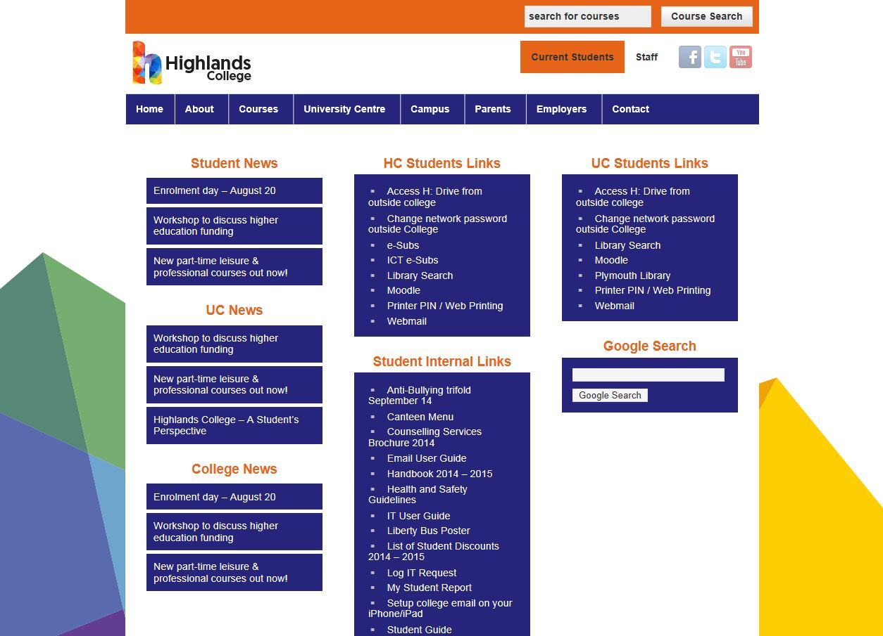

Photocopying, Printing, Scanning and Binding

Photocopying, colour printing and binding materials can be purchased from the library at the following prices:

|  |  |
| --- | --- |
| Colour Photocopier |  |
| A4 Single Copy | 10p |
| A3 Single Copy | 20p |
|  |  |

|  |  |
| --- | --- |
| Binding |  |
| Spiral Binding (ask at Porter’s Lodge) | £2.00 |
| Slide Binder | 10p |

Students are not charged for printing in black and white but there is a charge for colour copying and printing. Your print budget, credited to £3 at the beginning of the academic year by the college, can be topped up at the LRC Desk.